Shabbos Stories For
Parshas Tzav 5786
Volume 17, Issue 29 10 Nissan/March 28, 2026
Printed L’illuy nishmas Nechama bas R’ Noach, a”h

The Reluctant Chazan

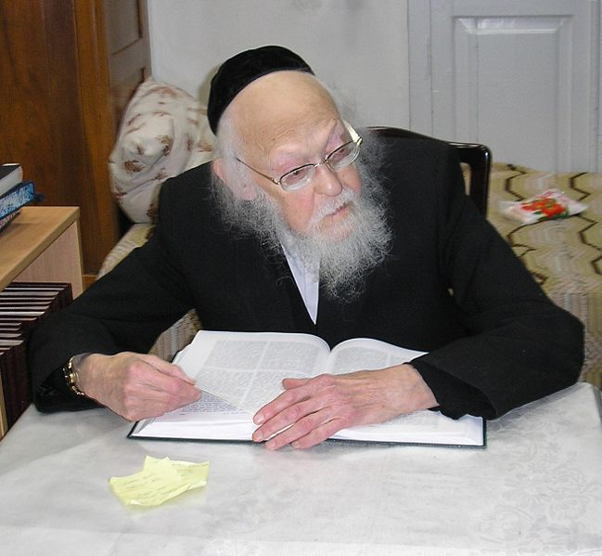
Rav Yosef Sholom Elyashiv, zt”l

Rav Yisroel Pesach Feinhandler (Avnei Yashfei, Tefilah) wrote about a case that occurred. A certain town had only two Minyanim for Shacharis, one at Neitz (K’Vasikin, sunrise), and the other at seven o’clock.
The Chazan for the seven o’clock Minyan moved away from the town, and since the people attending this later Minyan didn’t feel comfortable leading the Davening, the Minyan was left without a Chazan. They then remembered that there was a very talented Chazan who was a regular at the Neitz Minyan, and they thought
of hiring him to be their Chazan.
When they approached him, however, he explained that he was not interested. He said, “I would love to help you, but I just can’t give up on my regular Minyan. The Halachah says that someone who regularly Davens K’Vasikin is better off Davening alone than with a later Minyan. How can I lose out on such a special Zechus?”
But those who had approached him felt his position was selfish and wrong. They admonished him and said, “But you know that those who attend the later Minyan simply cannot Daven for the Amud as the Chazan. Some are not fluent enough in the Tefilos, while others Daven too slowly. All of us have never been a Chazan before. Do you really think that it would be better for you to Daven at the ideal time while abandoning your fellow Jews? What about Chesed? Isn’t that also important?”
But the Chazan would not budge. He said, “If one of the great Poskim rules that I am obligated to help you, I will do as I am told. But without that, I disagree.”
The people approached Rav Yosef Shalom Elyashiv, zt”l, who ruled that the Chazan was wrong. He said, “A person who is needed by the community to serve as the Chazan for Shacharis should not pursue his ideal of Davening at Vasikin. Instead, he should serve as the Chazan for the Minyan that really needs him!”

Reprinted from the Parshas Ki Sisa 5786 email of Rabbi Yehuda Winzelberg’s Torah U’Tefilah
Parnassah Comes
From Hashem

By Rabbi David Ashear

Parnassah comes only from Hashem, and therefore it does not have to operate according to normal human calculations. If somebody needed more money, it would seem illogical for him to give away what he already has.
Yet Chazal tell us: עשר בשביל שתתעשר — give away ten percent so that you will become wealthy. The very actions that appear illogical according to our reasoning often become the very source of blessing that brings a person more parnassah.
When we show that we truly believe our parnassah comes only from Hashem — by, so to speak, putting our money where our mouths are — those actions activate even more blessing.
A woman we will call Rachel, who runs her own business, recently received a call from a customer who usually places large orders with her twice a year. The customer told her she planned to make her regular order again and would soon get back to her with the details about colors and styles.
A few days later the customer called back. She explained that another woman she had recently become close with was asking her to give her the order instead. She said she really wanted to switch and help this other woman, but because she had already told Rachel that she would be ordering from her, she planned to ask a rabbi if it was permitted to back out.
Rachel, who firmly believes that all of her parnassah comes from Hashem, told her, "It makes no difference to me which customer my parnassah comes through. If you truly want to switch, you have my blessing."
The woman was very impressed with Rachel's emunah and thanked her for allowing her to switch. Practically speaking, this probably meant Rachel would permanently lose a steady customer.
Just a few minutes later, Rachel received a phone call from someone who had never ordered from her before. The order this person wanted to place was more than double the one she had just given up.
Later that night Rachel called the first customer back and told her not to feel guilty at all for switching, because Hashem had already replaced the loss and even given her more. The woman then told her she had just discovered that the other seller's prices were not as good as Rachel's, and she felt bad for having switched.
With Hashem's help, Rachel would now likely have that customer returning in the future — in addition to the new one she had just gained. She demonstrated her emunah, and immediately saw blessing from it.
A man we will call Daniel related another story. One day he received a phone call from the rabbi of his brother's shul. The rabbi asked Daniel if he could help resolve a difficult situation involving his brother. His brother owed someone money and had not paid it back, and the matter had created significant tension.
The rabbi said, "For the sake of shalom, this issue must be resolved. If it continues like this, I may have to start paying the debt myself."
Daniel was not a wealthy man, but he said to the rabbi, "For the sake of shalom, I will pay." He gave the rabbi his credit card and told him he would cover the amount in installments.
Just like that, the issue was resolved.
Less than ten minutes later, a neighbor called Daniel and asked if he remembered helping him many years earlier. Daniel had forgotten, but the neighbor reminded him of the favor he had done for him twenty years before.
The neighbor then told him that he had recently made some money and wanted to repay Daniel for the kindness he had shown him back then. The amount he gave him was far greater than the amount Daniel had just committed to pay for his brother.
Hashem can provide a person with parnassah in unlimited ways. Very often, when a person performs righteous acts that involve giving up money, Hashem blesses him with even more in return.

Reprinted from Living Emunah
Forgiveness

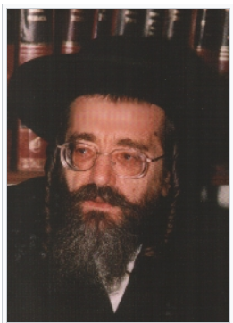
Reb Yaakov Meir Schechter

Rabbi Biderman shares a story from Reb Yaakov Meir Shechter Shlita: Baron Rothchild had a clever manager who took care of all the Baron’s businesses. The Baron became extremely wealthy due to this manager’s counsel and skills. Naturally, the Baron promoted him to a very high position. There was a problem, though. The manager understood the Baron’s success was due to his management, and he became haughty. He treated his boss, Baron Rotchild, with so much disrespect that it appeared as if the Baron was working for him!
Initially, the Baron accepted this situation. He figured it was worthwhile for him to suffer some humiliation from his manager if his businesses were prospering. But as time went on, matters became worse. The manager almost entirely disregarded the Baron’s opinion and did what he felt was better. The Baron fired him.
The manager wasn’t afraid of that. He was certain that many other wealthy people would hire him to run their businesses. He had a lot of experience, and he had made the Baron wealthy; who wouldn’t want to hire him? But he remained unemployed for months. No one was hiring him, and he didn’t know why. He began to advertise that he was looking for a position, but it didn’t help. His savings were shrinking, and he felt the need to find a position, quickly.
After investigating, he found out that when wealthy people considered hiring him, they would speak to Baron Rothchild to ask about him. The Baron would reveal to them that with time, the manager will begin to feel like he is the boss and will begin making his own decisions. Furthermore, he will totally disregard and humiliate his boss. This report prevented him from being hired.
The manager told his family what was happening to him. They replied, “The Baron is renowned for being a kind person. He certainly doesn’t hate you or want to take revenge on you. It must be that he knows that if you are hired, you will be fired soon afterwards because no one can possibly tolerate your behavior. The Baron figures that your emotional well-being shouldn't be hired to another position, rather than to be hired and fired soon afterwards."
The family said, “Therefore, you shall do the following: Tell the Baron that you recognize what you did wrong, and that from now on, you will always recognize your place, that you are merely a hired worker, and you won’t act like the boss. When you tell him this, you will see that he will speak favorably about you to others. Even more, he will hire you once again because the Baron knows, more than anyone else, the good job you can do.”

Reprinted from the Parashat Ki Tisa Dvar Torah of Jack Rahmey based on the Torah teachings of Rabbi Amram Sananes.

The Salvation of
Giving Charity

Rabbi Shlomo Landau shares a story about the Minzer family who ran a bakery near Krakow during the start of World War II. The bakery always gave free bread to the poor, travelers and charity collectors that passed by. When refugees started pouring into their town, their charity increased and their ovens never cooled.
When the Nazis took control of their town, they transferred ownership to a non-Jew who decided to repay the favor and feed the Minzer family and other Jews in need. When the Minzers were forced into ghettos and some of the Minzer sons volunteered to work in the tin factory. The Polish owner of the factory hated Germans, and the Minzers helped him hinder German production. Every night the owner would bring the Minzer boys about forty rolls of bread which they were able to eat and sell.
When the country became too dangerous the factory owner helped the Minzer family escape and they miraculously survived the war. Looking back the Minzers attributed their survival and that they always had what to eat to their charity before the war. The word machatzit teaches that when you give charity, you will have life; but if you don’t, it may lead to the opposite, chas veshalom. As the passuk says, “Tzedaka tatzil mimavet — charity saves from death!”

Reprinted from the Parashat Ki Tisa Dvar Torah of Jack Rahmey based on the Torah teachings of Rabbi Amram Sananes.

The Power of Speaking
With One’s Eyes
By Rabbi Reuven Semah

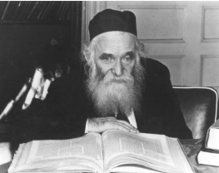
Rabbi Aharon Kotlerr

The atmosphere a person finds himself in can deeply affect him for good or otherwise. Being in a holy atmosphere or in the very presence of a great person can, like being in the proverbial perfume store, surround the person with a “pleasant scent” of holiness and purity.
Rav Avrohom Pam would repeat a remarkable story relevant to this topic, which he heard from the esteemed R’ Peretz Steinberg of Queens. R’ Steinberg’s father, Alex Steinberg, was a wealthy businessman and generous philanthropist. He once organized a fund-raising parlor meeting in his home to benefit Bet Midrash Govoha of Lakewood, and the guest Rabbi would be the Rosh Yeshivah, R’ Aharon Kotler. Alex invited his friends, neighbors and business associates, among them a non-religious neighbor, who came because he was told there would be good food and an address by a “famous Rabbi.”
After the buffet was served, the assembled sat down to listen to the guest speaker. This man sat right in front of Rav Aharon. The Rav, instead of giving a speech, delivered a complicated shiur. As is well-known, Rav Aharon’s shiurim were extremely complex, and his rapid-fire delivery often made his profound words comprehensible only to the most seasoned talmid hacham.
When he finished, the parlor meeting ended, and the non-religious man stood up to say good-bye to the host, Mr. Steinberg. With a serious look on his face, the man said, “You know, Alex, I didn’t understand one word the Rabbi said. However, I know that now I’m going to live differently.”
“What happened?” asked Mr. Steinberg.
“I don’t know, but the Rabbi ‘spoke’ to me with his eyes and asked why I did not keep the Sabbath.”
This man’s remarkable turnaround came about because of his one-time exposure to the “sweet and pleasant” that surrounded the radiant presence of Rav Aharon. The man’s proximity to him for a mere half hour listening to a lecture in Lithuanian Yiddish about which he understood nothing at all left such an impression on him that it effected this profound change in his life!

Reprinted from the Parashat Yitro 5786 email of Rabbi David Bibi’s Shabbat Shalom from Cyberspace.

Proof that Hashem
Runs the World!!!

Rav Binyomin Pruzansky shared a story about a young man from Yerushalayim who was diagnosed with liver failure, R”L, and he needed an urgent transplant. Doctors advised his parents to bring him to Brussels, which was considered a world center for liver transplants.
But there was a serious obstacle. Citizens were given priority over noncitizens
for organ transplants, and there was a long list of local patients who were already waiting. The doctors in Eretz Yisroel did not believe that this young man had much time left.
In despair, he went to see his Rebbe, and he said, “There is a strong chance that I will not live long enough to receive a transplant. Why should I bother to go to
Brussels? I would rather remain here in Eretz Yisroel and spend my final days surrounded by family.”
The Rebbe responded with unwavering clarity. He said, “Hashem runs the world. He can do anything. You do your part. Let Hashem do His.” Strengthened by those words, the young man traveled to Brussels.
As expected, he was placed at the bottom of the transplant list. The doctors told him to find a residence near the hospital. They told him that if a liver became
available and no citizen matched, he would need to be ready within twenty-four hours. This young man spent his days learning Torah and pouring out his heart in Tefilah.
At that time, a volcano in Iceland erupted, and it sent massive clouds of ash across Europe.


The Eyjafjallajokuil volcano that erupted in Iceland on April 14,2010, resulting in the closing the European air space for ten days.

The dark skies turned the continent into a wide no-fly zone. All flights were grounded, and air travel came to a standstill. The next day, in a nearby hospital in Brussels, a liver became available for transplant. Every person above the young man on the list needed to fly in for the procedure. Under normal circumstances, they would have arrived within hours.
But with European airspace shut down, no one could reach Brussels in time. There was only one candidate who was nearby. It was the young man from Eretz Yisroel who was at the very bottom of the list, and he received the transplant.
After surgery, the doctors told him that his own liver would not have lasted more than a few days. The timing was precise beyond comprehension! An entire continent was brought to a halt so that one Jewish neshamah could live. Hashem moves mountains and stills skies for His children!
Reprinted from the Parshas Ki Sisa 5786 email of Rabbi Yehuda Winzelberg’s Torah U’Tefilah

It’s Written on My Forehead
By Rabbi Eluzer Elimelech Kowalsky

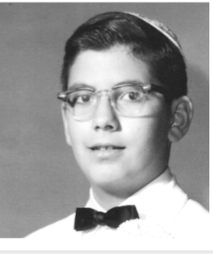
Photo of Rabbi Eluzer Eimelech Kowalsky
from his 1964 Bar Mitzvah celebration

As a young yeshivah student in 1939, my father, Rabbi Sholom Dovber Kowalsky, had an inkling that there was going to be a war in Europe. His father, Rabbi Chaim Nachman Kowalsky, was a staunch Lubavitcher chasid, and had sent him to study in the Chabad yeshivah in Warsaw.
Shortly before the war, he had been accepted to the prestigious Yeshivas Chachmei Lublin, but then he heard a man named Ze’ev Jabotinsky give a speech warning the Jews to leave Europe. My father decided to take action. Without permission from his family, he borrowed a few hundred dollars, took a volume of the Talmud – Tractate Shabbat – got on a boat, and went to America.
His parents and two sisters followed him shortly after, getting out just before the war. My father received his rabbinical ordination from the Ner Yisrael yeshivah of Baltimore, and after I was born in 1951, he went on to serve in rabbinic positions in New Bedford, Massachusetts, and later as the rabbi of Young Israel of Hillcrest, in Flushing, Queens. In between, we also lived for a couple of years in Crown Heights.
When we moved to Hillcrest, and I was eight years old or so, my family went to receive a blessing from the Lubavitcher Rebbe. I didn’t know any Yiddish, or much of anything about the Rebbe, except that he was a very holy man. At one point during the audience, the Rebbe opened his drawer and gave me a little Mincha-Maariv – a small prayer book for the afternoon and evening services – as a gift.

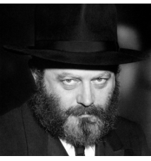
The Lubavitcher Rebbe

The next time I came back was before my Bar Mitzvah. This time the Rebbe gave me a full prayer book, as well as his blessing for the occasion. That visit endeared me more to the Rebbe and to Lubavitch and I began praying according to the Chabad custom, like my grandfather had done.
In tenth-grade, I was attending Williamsburg’s Torah Vodaath yeshivah, spending all week in the dormitory and coming home every Shabbat. One week, my father invited two or three young men from Lubavitch to Young Israel of Hillcrest. They spent Shabbat with us, shared chasidic teachings, and as a gift, they gave me a copy of the Tanya, the foundational work of Chabad philosophy; later on, I also attended a weekly class on the Tanya.
On Sunday mornings, I used to schlep back to Torah Vodaath with a fellow named Freddy who was a few years older than me. He would drop me off at the foot of the Williamsburg Bridge, a few blocks away from the yeshivah on South 3rd Street.
That particular winter weekend, the weather was bad. Sunday morning was cold and there was freezing rain. So, I asked Freddy if he could take the Metropolitan Avenue exit off the Brooklyn-Queens Expressway and drive me, along with a friend of mine who joined me for that Shabbat, straight to the yeshivah. Being a very nice fellow, he agreed to take us to the door. As he drove, we became engrossed in conversation, until suddenly I realized that we were passing Metropolitan Avenue. “Freddy!” I said with a start, “That’s the exit!”
The road was empty, so he made a quick turn. But we were going 50 miles an hour, so the car slid, and then it slammed into a solid cement wall. It was an old-style Mercury with no seat belts, so I flew out of my seat, and my head went through the windshield. I was out cold and in really bad shape. Once I was taken to the hospital, the police got a hold of my father. “Rabbi, you’d better hurry,” they told him. “We don’t know if he’s going to make it.”
Before he came, though, my father called 770 and spoke with Rabbi Leibel Groner, the Rebbe’s secretary, with whom he had a good connection. He gave Rabbi Groner my name, and asked if the Rebbe could pray for my recovery. Thank G-d, after the second or third day, I started coming back to consciousness. I have no memories of those first couple of days – at first, I didn’t even know who I was. I was severely concussed, and I ended up with over ninety stitches on my forehead and over my eyes. After being laid up in Long Island Jewish Hospital for a while, I came home and recovered for a few weeks until I was ready to return to yeshivah.
“We have to go to 770,” my father told me, once I was able to get out of the house. We went there for the afternoon prayers, which the Rebbe prayed in the smaller study hall near his office. When the Rebbe was returning to his office after the service, my father approached him. “This is my son,” he said, presenting me. “The one I called the Rebbe about.”
The Rebbe turned to me and said, quoting the words of the prophetess Chanah in the Book of Shmuel, “For this boy, did I pray.”
Hearing this from the Rebbe, in no uncertain terms, took me aback. I felt a personal sense of gratitude, but my eyes opened up to something beyond that: Here is a man leading hundreds of thousands of people all over the world, and yet he has the time to care about every single Jew – even this fourteen-year-old kid.
The Rebbe’s prayers had their effect: He interceded on my behalf and G-d saved me! Thank G-d, I had a full recovery, except for one thing: One of my teachers in Torah Vodaath, a Breslover chasid named Rabbi Wasilsky, told me not to do plastic surgery to clean up my forehead. “You should leave a sign to remember the great miracle,” he advised me, “and to remember that the Rebbe prayed for you.” So I still have some scars to remember this story today.
______________
Alongside a career in finance and computer science, Rabbi Eluzer Elimelech Kowalsky has worked extensively in the field of kosher supervision. Semi-retired and a longtime resident of Midwood, Brooklyn, he was interviewed in January 2024.

Reprinted from the Here’s My Story [with the LubavitcherRebbe, zt”l], a project of JEM (Jewish Educational Media.]

An Inspiring Story of the Ahavas Yisrael of Vizhnitz
By Yehuda Z Klitnick

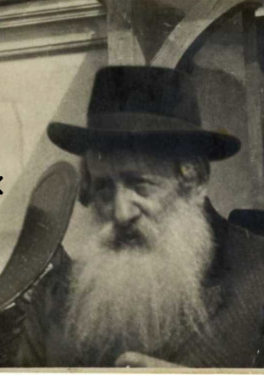

Harav Yisrael Hager, the Rebbe of Viznitz, the Ahavas Yisrael, is the subject of an interesting story. He was born 2 days in Elul 5620. He was the firstborn son of Rabbi Boruch Hager, the Imrei Baruch. He married the daughter of Rabbi Meir Horowitz the Rebbe of Dzikov. In 1875 he moved to his father-in-law’s house and studied at great length with his brother-in-law Rabbi Yehoshua of Dzikov the Ateres
Yehoshua.
Harav Yisrael passed away two days in Sivon 5696. After surviving World War II and immigrating to Israel, Harav Chaim Mayer Hager, also known as the Imrei Chaim, succeeded his father Harav Yisrael. Eight days of Nisson 5732, the Imrei Chaim passed away in Bnei Brak.

The Rebbe’s Frequent Visits
to Spa Town of Karlsbad
The Viznitzer Rebbe, Harav Yisrael, used to frequent the town of Karlsbad, Germany, a spa and vacation destination known for its hot springs. Mr. Morris, a secular Jew, visited the baths at that time as well for his own health. He was informed one day via certified mail that he was facing charges for a crime he accused of, and
that he needed to show up in court on a specific day.
Mr. Morris was terrified and afraid because he knew he would have to serve a lengthy jail sentence if found guilty. He was a diligent worker with a small income who couldn't afford to hire a strong defense attorney He was condemned and looked tortured and despondent.
Noticing the anguish on his friend's face, Mr. Hansberg asked him, "What occurred to you? I recognize you as a truly cheerful individual who is always smiling.

Reveals His Horrifying Story
Mr. Morris revealed his story and became increasingly open with his friend Mr. Hansberg. To reassure Mr. Morris, Mr. Hansberg clarified that the famous Rebbe of Viznitz was at the resort and was known for performing miracles, so, he needn't be concerned. He can certainly assist you in your dire predicament.
Mr. Morris held a strong aversion to Rebbes; in truth, he loathed them and was firmly opposed to meeting one. After initiating a dialogue, Mr. Hansberg straightforwardly asked, "What does he have to lose by meeting the Rebbe?"
Mr. Morris ultimately agreed to meet the Viznitzer Rebbe as he recognized his situation and was in urgent need of salvation Mr. Morris felt a little calmer standing in front of the Rebbe, who smiled warmly and welcomed him. What was
upsetting him, the Rebbe asked him?
The Rebbe listened to him tell his story.
"Is there anything I can help you with?" inquired the Rebbe.
"I need to hire a good lawyer to defend me, but I have no money for a lawyer," the Jew replied.
"How much money do you need for a lawyer?" inquired the Rebbe.
Mr. Morris responded with the number he required.
"You need not worry; here is the entire amount of money you require," the Rebbe remarked. You will get back to me with the good news once you have been acquitted in the case. You should worry about paying me back after that!

Amazed by the Rebbe’s Trust in Him
Mr. Morris was taken aback by this: here is a Rebbe who has never met him and doesn't even know him, yet he trusts me with this much money! His attitude toward the Rebbe had changed, and he thanked him and requested his blessing to succeed in court.
After delivering his bracha, the Rebbe bid him farewell. After expressing gratitude to the Rebbe, Mr. Morris sought the advice of a renowned attorney who examined the court documents and expressed confidence in his ability to win the case, albeit at a significant cost.
In response, Mr. Morris said he had the necessary funds and that a contract had been created. The attorney got to work on the matter, and he made his defense in court. Mr. Morris was cleared of all charges. Mr. Morris compensated the attorney after expressing his gratitude.

Not an Easy Task in Repaying the Rebbe
He began to take loans to repay the Rebbe. It was not an easy task, yet he managed to gather the complete amount and departed to visit the Rebbe after investing significant effort. He approached the Rebbe, conveyed the positive update, and asserted he had the money to repay the loan.
He was stunned to discover, however, that the rebbe had refused the money, stating that Hashem had already rewarded him with other resources and that hence the money could not be accepted.
Mr. Morris, who had never experienced such kindness and dedication from another Jew, was genuinely moved by this and started to cry, telling the Rebbe: I wish to repent and become a G-d-fearing Jew. He implored the Rebbe to guide him toward genuine repentance.
Once Mr. Morris accepted the Rebbe's invitation to learn with him, he swiftly adopted the Torah lifestyle and Judaism, becoming a devout Yid. A Yid rediscovered his Torah roots thanks to the Rebbe's kindness and Kiruv efforts. Mr. Morris went to thank his friend Mr. Hansberg, to whom he owed a great deal. They studied Torah together and developed a close relationship! This is a great illustration of the advantages of showing kindness to another Yid.

Reprinted from the Parshas Ki Sisa 5786 email of Pardes Yehuda.

